##### This instruction only applies to the XU2.0 inventory system.

##### In the inventory system 2.0, press the G key on the side and you will find an option for TF card management.

## A note about TF2:

Format the memory card into **exFAT** format.

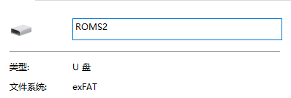

Double click to open.

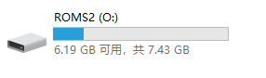

Create a new folder in the root directory of the memory card, and rename the "New Folder".

Take putting in a psp game as an example.

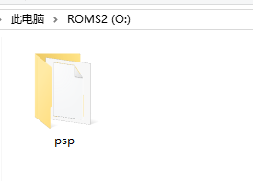

Put the psp game with the suffix name .cso into the psp folder and you're done.

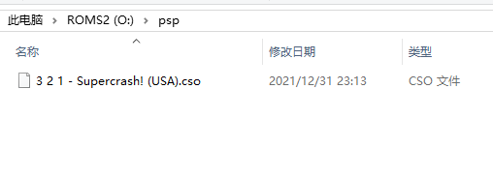

Introduction to all emulator folder names：

|  |  |  |
| --- | --- | --- |
| Folder name | Emulator name | 游戏名后缀 |
| arcade | Arcade | .zip |
| atari7800 | Atari7800 | .zip |
| atarilynx | Atarilynx | .zip |
| capcom | CAPCOM | .zip |
| cps1 | CAPCOM1 | .zip |
| cps2 | CAPCOM2 | .zip |
| cps3 | CAPCOM2 | .zip |
| dreamcast | DC | .chd .cdi |
| famicom | NES/FC | .nes |
| fds | Famicom Disk System | .zip |
| Gameandwatch | Game And Watch | .mgw |
| gamegear | Game Gear | .gg |
| gb | Game Boy | .7z |
| gba | Game Boy Advance | .7z .zip |
| gbc | Game Boy Color | .zip |
| mame | MAME | .zip |
| mastersystem | Sega Master | .7z |
| megadrive | MD | .zip |
| msx2 | Msx2 | .zip |
| n64 | N64 | .n64 |
| naomi | Naomi | .zip .bin |
| nds | Nintendo ds | .zip |
| neogeo | Neo-geo | .zip |
| nes | NES/FC | .zip |
| ngp | Neo-geo pocket | .zip |
| ngpc | Neo-geo pocket color | .zip |
| openbor | Openbor | .pak |
| pcengine | Pc engine | .zip |
| ports | Ports | .sh |
| psp | PSP | .cso .iso |
| psx | PS1 | .PBP .bin .chd |
| saturn | Saturn | .cue .chd |
| sega32x | System SEGA 32X | .7z |
| sg-1000 | Sega sg1000 | .zip |
| snes | SNES/FC | .zip .7z |
| wonderswancolor | Wonderswan Color | .7z |

